|  |
| --- |
|  |
| **INSURANCE CHATBOT Documentation** |
|  |

|  |
| --- |
|  |

|  |  |  |  |
| --- | --- | --- | --- |
| |  |  |  | | --- | --- | --- | |  |  |  | |

Contents

1. OBJECTIVE 3

2. BOT WORKFLOW 4

2.1 POLICY WORKFLOW 4

2.1.1 AUTO POLICY QUOTE GENERATOR FLOW 5

2.1.2 BILLING AND PAYMENTS WORKFLOW 6

2.2 CLAIMS FLOW 7

2.2.1 ACCIDENTAL CLAIM & GENERAL CLAIM 7

2.2.2 UPDATE MY CLAIM 8

2.2.3 CHECK CLAIM STATUS 9

2.2.4 CANCEL MY CLAIM 10

# OBJECTIVE

With the world becoming more digital by the day, Customer (policyholder/policyowner) expectations change. If an agent isn’t available to offer relevant information, the potential customer goes on to find another provider. With chatbots in place, insurance companies/firms can proactively interact with the customer to improve service across all spheres of activities towards high customer retention. Overall, this will lead to better customer experience at all levels.

# 2. BOT WORKFLOW

The flow is split into two parts in general, first part being entirely related to Policy Management including Billing (premium payment) and the second part for Claims Management.

## POLICY WORKFLOW

This proposed flow manages all actions across a policy like Adding a new policy, Viewing existing policy, Edit policy type , Renew policy and Cancel policy. Certain parts of the flow are summarized into a different workflow for ease of access. This is specific to Auto Insurance.

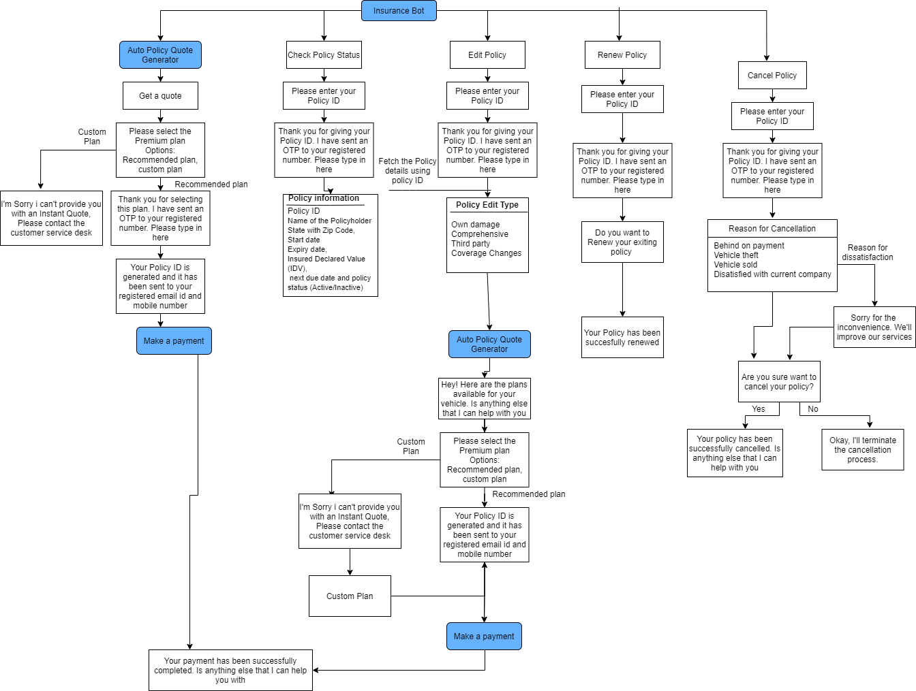

## AUTO POLICY QUOTE GENERATOR FLOW

This flow concentrates on saving multiple vehicle and personal information and creating a quote for a new policy, the quote can be either generated with existing templates or can be custom made by contacting a customer service desk

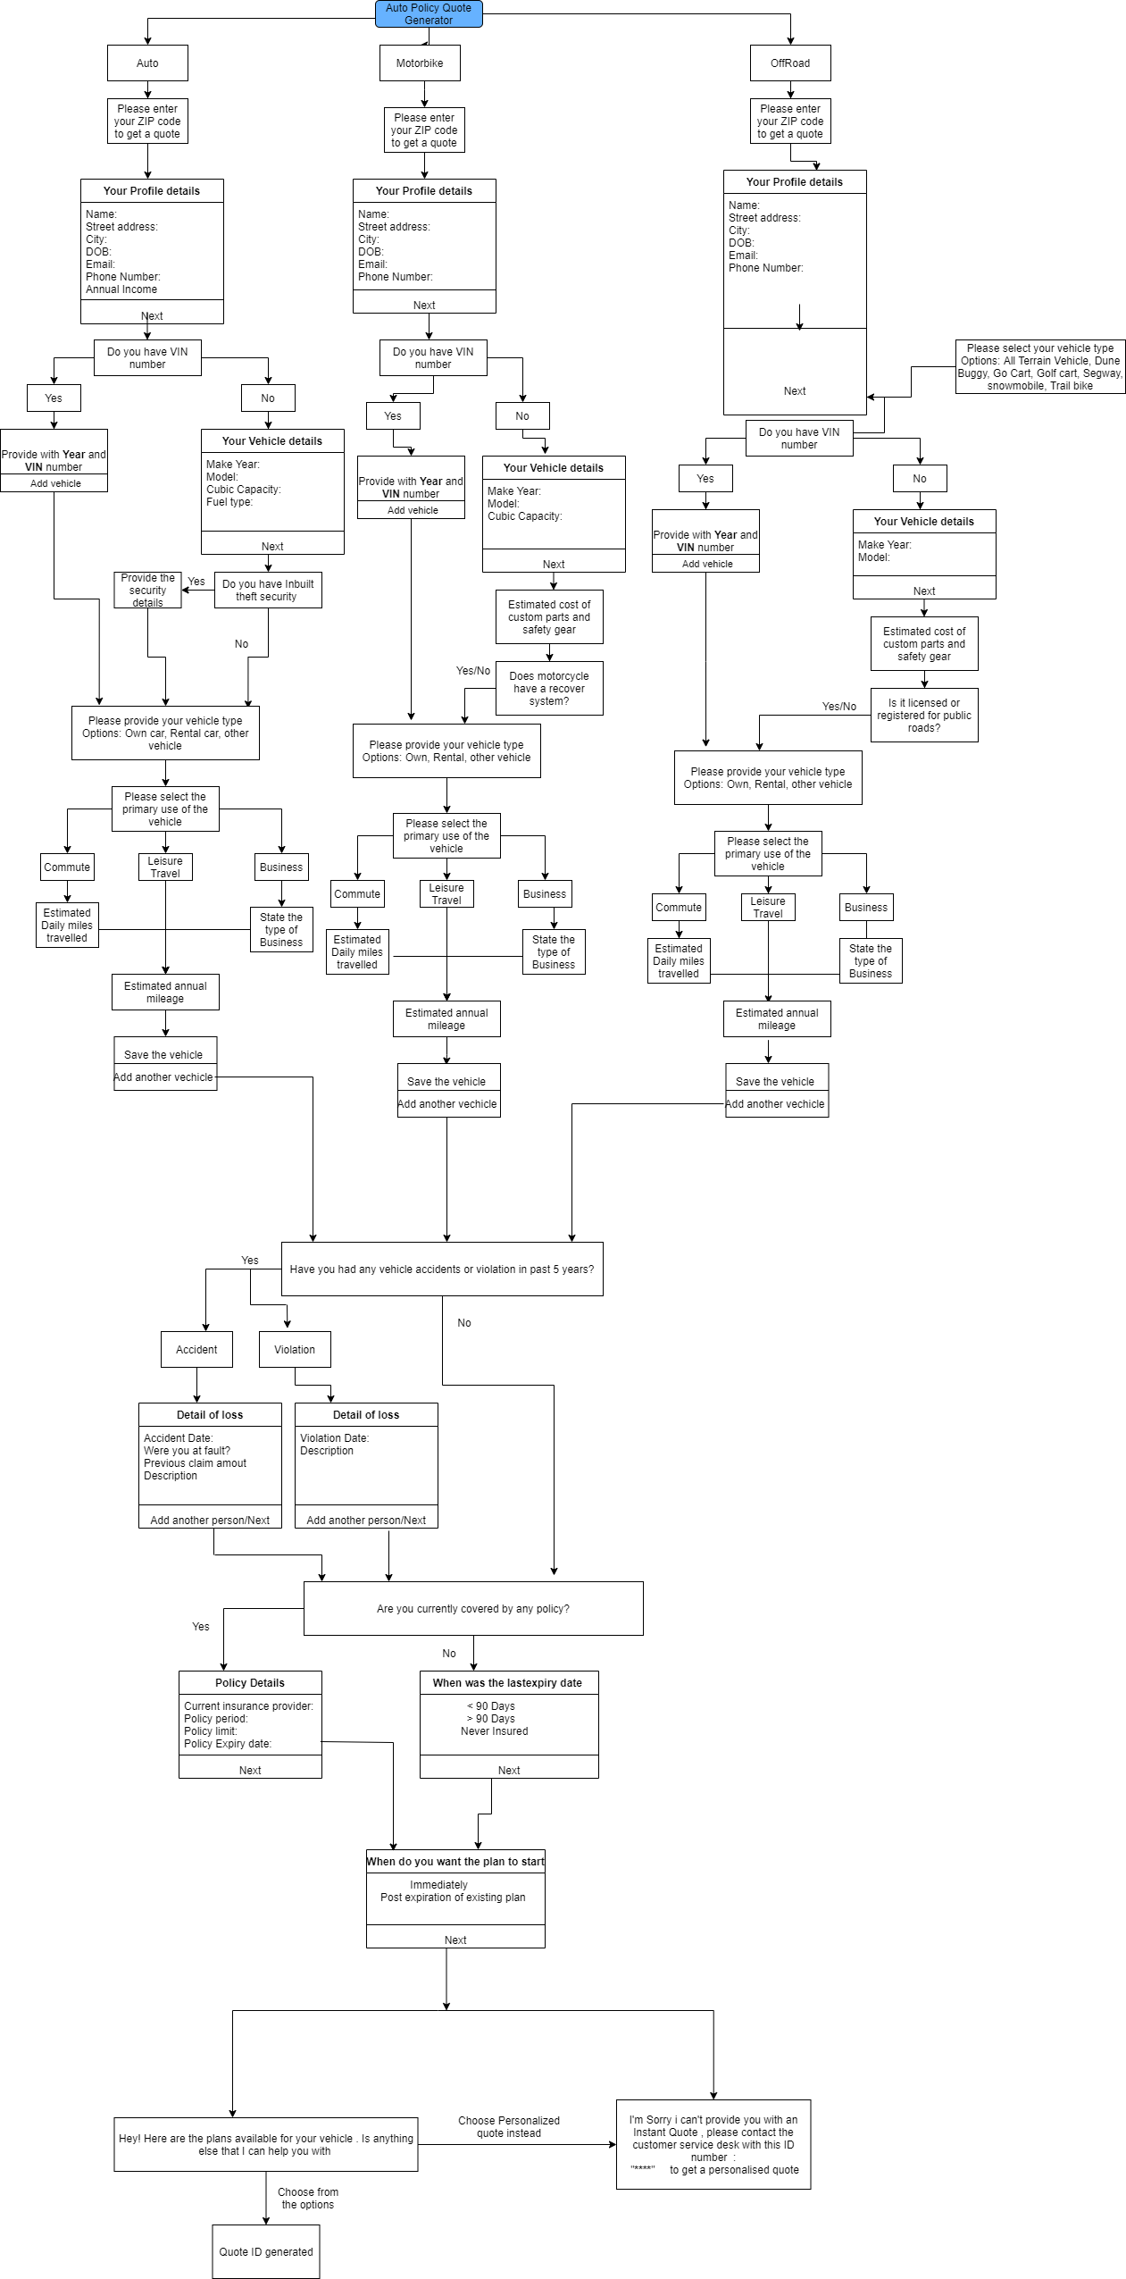

## BILLING AND PAYMENTS WORKFLOW

This flow takes care of making premium payment for a Policy ID, post validating the user. All selected or changed policy gets passed to this workflow using a Policy ID. Validation is in place to maintain security during payments. This workflow handles all incoming transactions through premiums.

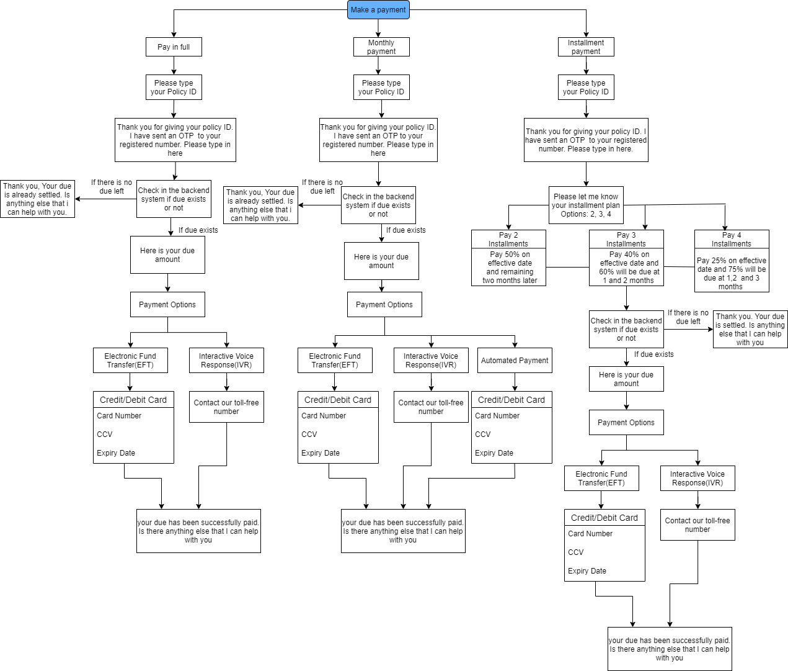

## CLAIMS FLOW

## ACCIDENTAL CLAIM & GENERAL CLAIM

The flow is working fine as shown in the below figure. Besides **Registered Body Shop**, the flow is working fine as shown in the above figure. For registered body shop, it throws an error message like **Sorry, that's an invalid zip code. Please try someother**.

## UPDATE MY CLAIM

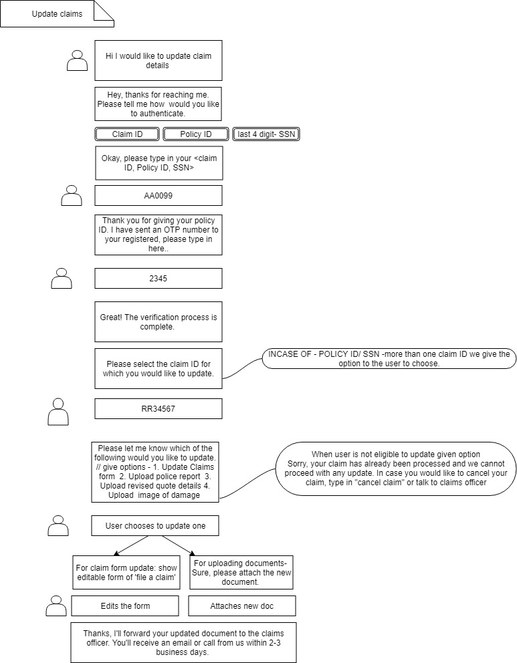

The update claim flow is working fine as shown in the above figure.

## CHECK CLAIM STATUS

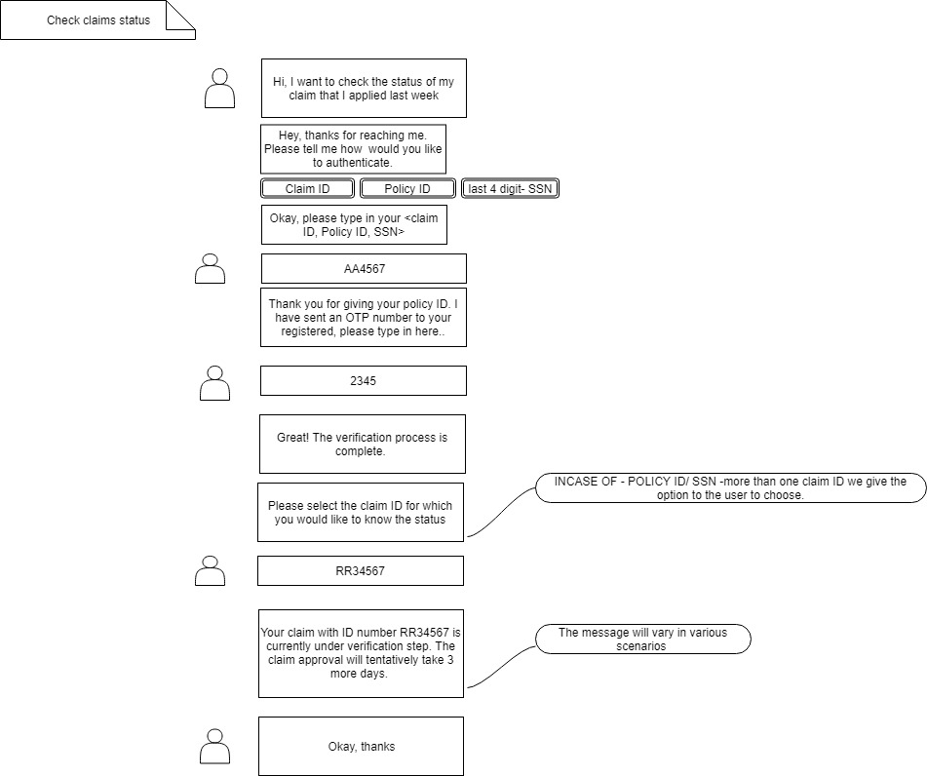

The flow is working fine as shown in the above figure.

## CANCEL MY CLAIM

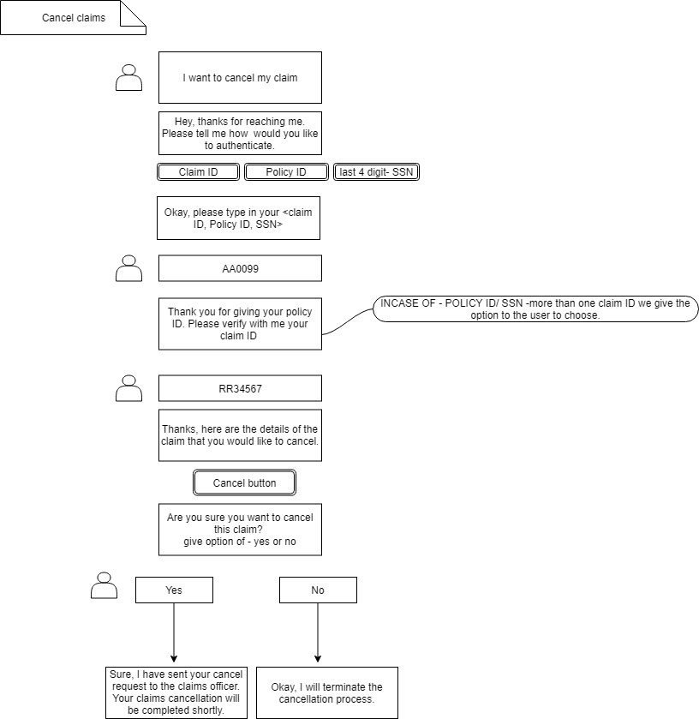

The cancel claim flow is working fine as shown in the above figure.